Name:

CIS 11 In-Class Assignment 1:

- Use place-holder method to convert the following decimal number to unsigned binary. *Subtraction is used to convert decimal to binary.
- Convert decimal number 149 to binary. Show your work below.
149 – 128 = 21 – 16 = 5 – 4 = 1 – 1 = 0
Binary | 0 | 1 | 0 | 0 | 1 | 0 | 1 |  | 1
Decimal | 256 | 128 | 64 | 32 | 16 | 8 | 4 | 2 | 1

- Convert decimal number 307 to binary. Show your work below.
307 – 256 = 51 – 32 = 19 – 16 = 3 – 2 = 1 – 1 = 0
Binary | 1 | 0 | 0 | 1 | 1 | 0 | 0 | 1 | 1
Decimal | 256 | 128 | 64 | 32 | 16 | 8 | 4 | 2 | 1

- Convert decimal number 48 to binary. Show your work below.
48 – 32 = 16 – 16 = 0
Binary | 0 | 0 | 0 | 1 | 1 | 0 | 0 | 0 | 0
Decimal | 256 | 128 | 64 | 32 | 16 | 8 | 4 | 2 | 1

- Using binary to decimal conversion placeholders, convert unsigned binary numbers into decimal. *Use addition method to convert binary to decimal.
Example: 0110110
32 + 16 + 4 + 1 = 48 + 5 = 53
Binary |  |  | 0 | 1 | 1 | 0 | 1 | 1 | 0
Decimal | 256 | 128 | 64 | 32 | 16 | 8 | 4 | 2 | 1

Add the decimal value of 1s’
32+16+4+2 = 54 decimal value of 01100110
- Covert binary number 10111101 to a decimal. Show your work below.
Binary |  | 1 | 0 | 1 | 1 | 1 | 1 | 0 | 1
Decimal | 256 | 128 | 64 | 32 | 16 | 8 | 4 | 2 | 1
128 + 32 + 16 + 8 + 4 + 2 = 160 + 24 +2 = 186

- Convert binary number 11001110 to a decimal. Show your work below.
Binary |  | 1 | 1 | 0 | 0 | 1 | 1 | 1 | 0
Decimal | 256 | 128 | 64 | 32 | 16 | 8 | 4 | 2 | 1
128 + 64 + 8 + 4 + 2 = 128 + 74 = 202
- Covert binary number 11100001 to a decimal. Show your work below.
Binary
Decimal | 256 | 128 | 64 | 32 | 16 | 8 | 4 | 2 | 1

- Convert binary number 00010110 to a decimal. Show your work below.
Binary |  | 0 | 0 | 0 | 1 | 0 | 1 | 1 | 0
Decimal | 256 | 128 | 64 | 32 | 16 | 8 | 4 | 2 | 1
16 + 4 + 2 = 22
- Adding binary:
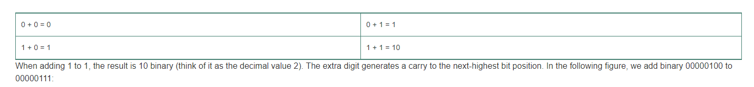
Example:
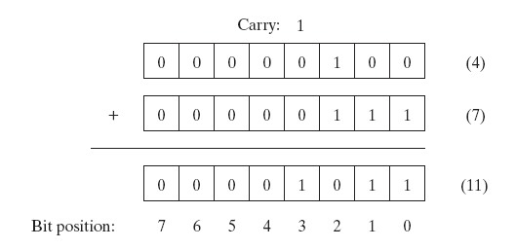
- Add the following binary:
1 0 1 0 1 1 0 1
+1 1 1 1 0 1 1 0
110100011
- Add the following binary:
0 0 1 1 0 1 1 1
+1 0 0 0 1 1 0 1
11000100

Convert Hexadecimal to Binary
Step 1: Split a binary value into groups of four, starting at the right-most side.
Step 2: For each group of four, consult the table above to find the matching hex value, and replace groups of four binary digits with the one hex value.

Example #1
Convert (4E)₁₆ to binary:
(4)₁₆ = (0100)₂
(E)₁₆ = (1110)₂
_{So}
(4E)₁₆ = (01001110)₂

- Convert hexadecimal 4B1C to a decimal value.
0010101100011100

- Convert hexadecimal 81BDF to a decimal value.
10000001101111011111

Convert Hexadecimal to Decimal:
Example: Convert 61453₁₀ to hexadecimal:
Step 1: Divide 61453 by 16. The result is a quotient of 3840, and a remainder of 13. That remainder becomes our first, right-most, least-significant hex digit – D. Take 3840 to the next step.
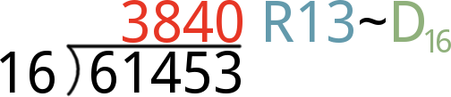
Step 2: Now divide 3840 by 16. The resulting quotient is 240 with a remainder of 0. Our second hex digit is 0, and we take 240 to the next digit.
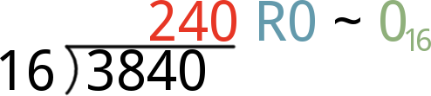
Step 3: Divide 240 by 16, and you’ll get 15 with another 0 remainder. Our third hex digit is 0, and take 15 to step 4.
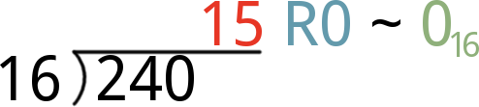
Step 4: Finally, divide 15 by 16. That’ll produce the 0 quotient we’ve been waiting for, with a remainder of 15. That remainder means the hex digit for this position if F.
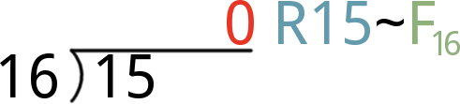
Finally, combine all four hex digits to create our hex value: 0xF00D.

Converting Hex to Decimal
There’s an ugly equation that rules over hex-to-decimal conversion:
There are a few important elements to this equation. Each of the h factors (h_{n}, h_{n-1}) is a single digit of the hex value. If our hex value is 0xF00D, for example, h₀ is D, h₁ and h₂ are 0, and h₃ is F.
Powers of 16 are a critical part of hexadecimal. More-signficant digits (those towards the left side of the number) are multiplied by larger powers of 16. The least-significant digit, h₀, is multiplied by 16⁰ (1). If a hex value is four digits long, the most-significant digit is multiplied by 16³, or 4096.
To convert a hexadecimal number to decimal, you need to plug in values for each of the h factors in the equation above. Then multiply each digit by its respective power of 16, and add each product up. Our step-by-step approach is:
- Start with the right-most digit of your hex value. Multiply it by 16⁰, that is: multiply by 1. In other words, leave it be, but keep that value off to the side.
  - Remember to convert alphabetic hex values (A, B, C, D, E, and F) to their decimal equivalent (10, 11, 12, 13, 14, and 15).
- Move one digit to the left. Multiply that digit by 16¹ (i.e. multipy by 16). Remember that product, and keep it to the side.
- Move another digit left. Multiply that digit by 16² (256) and store that product.
- Continue multiplying each incremental digit of the hex value by increasing powers of 16 (4096, 65536, 1048576, …), and remember each product.
- Once you’ve multiplied each digit of the hex value by the proper power of 16, add them all up. That sum is the decimal equivalent of your hex value.

Convert Unsigned Decimal to Hexadecimal.
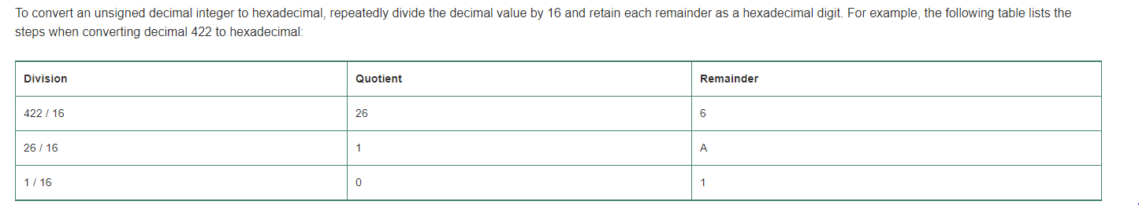
- Convert unsigned decimal 168 to a hexadecimal value.
168 % 16 = A8
- Convert unsigned decimal 60293 to a hexadecimal value.
60293 / 16 = 3768 R 5 / 16 = 235 R 5 / 16 = 14 R A = D
= DA55

Adding Hexadecimal
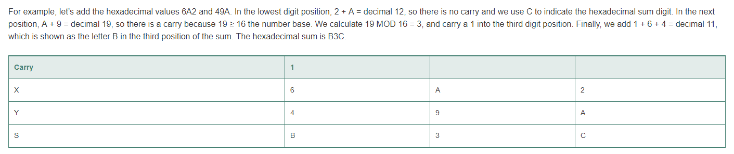
- Add the following hexadecimal values:
1 F 3 C₁₆
+7 8 B 2₁₆
97EE

- Add the following hexadecimal values:
D 6 0 4₁₆
+5 A 9 9₁₆
1309C

